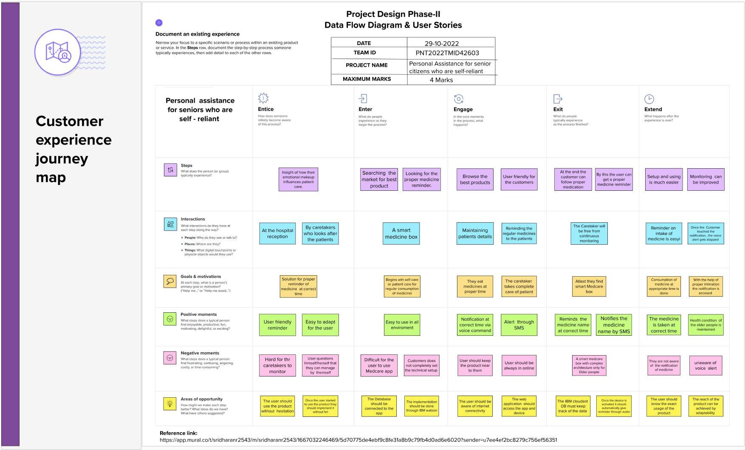

TEAM ID:PNT2022TMID10050